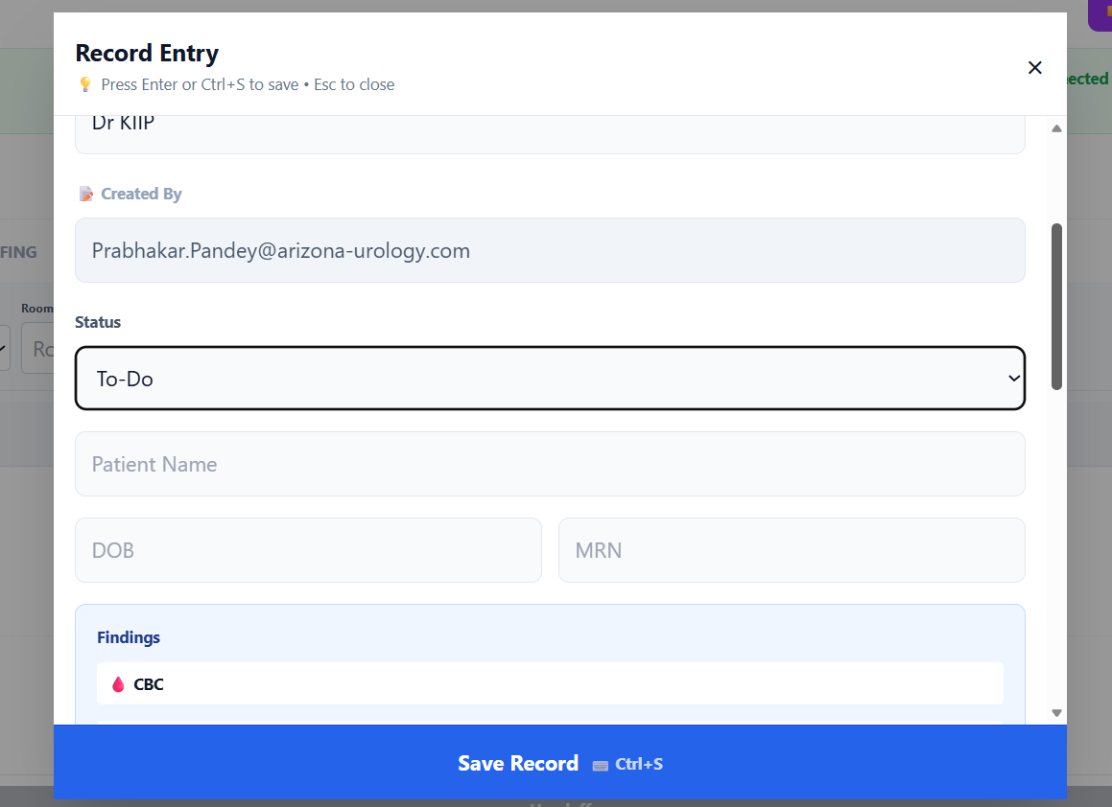

CURRENT STATUS:
To do | NEW CONSULT
In Progress | SURGICAL PATIENT (SAME DAY SURGERY)
 | NEW SURGICAL PATIENT (AM ADMIT)
 | FOLLOW UP (CONSULT)
Completed | FOLLOW UP (POST OP)
Post Op | TO BE DISCHARGED/SIGNED OFF

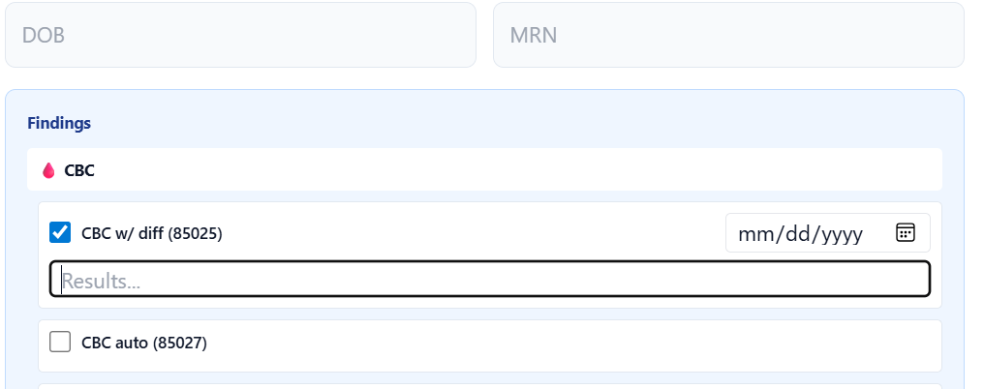

DOB: worth adding a calendar
CBC w diff:
WCC ____, Hb ____, Hct ____, Plt ____. Neutro _____% Lympho ____%, Mono ____%, Eosino ____%
Comments (if any)

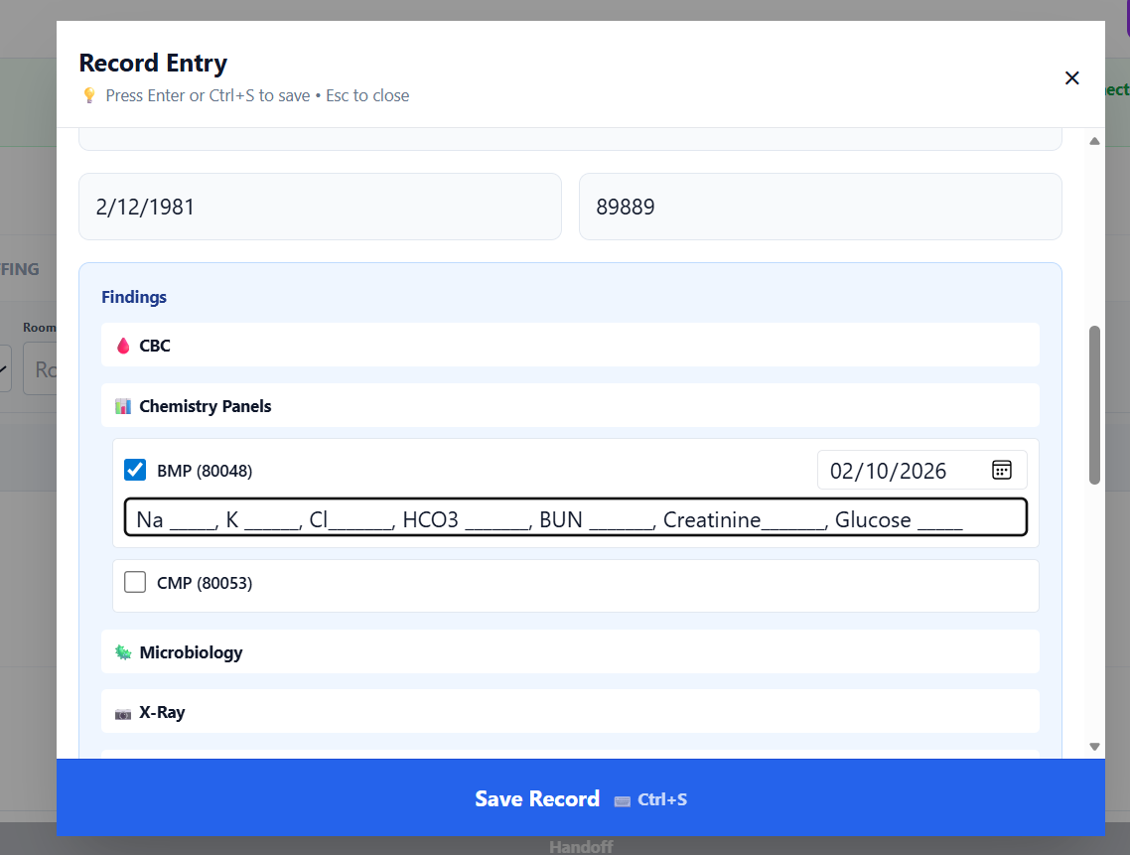

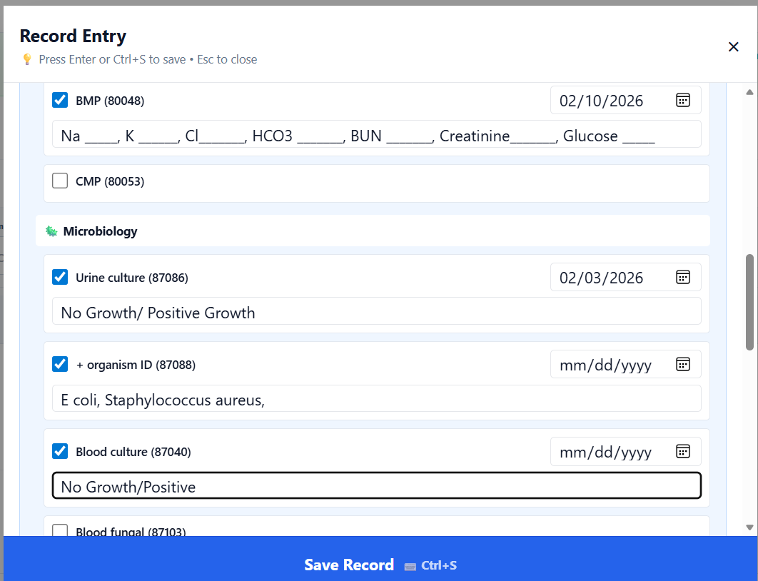
Microbiology Source:
Body Fluid | Body Tissue/Organ
Urine | Abscess Wall
Sputum | Stomach
Stool | Other
Blood
Joint Fluid
Other
Other | Name of Other

Growth:
NO GROWTH
POSITIVE GROWTH | Name of organism
Colony Count
Resistance
Sensitive

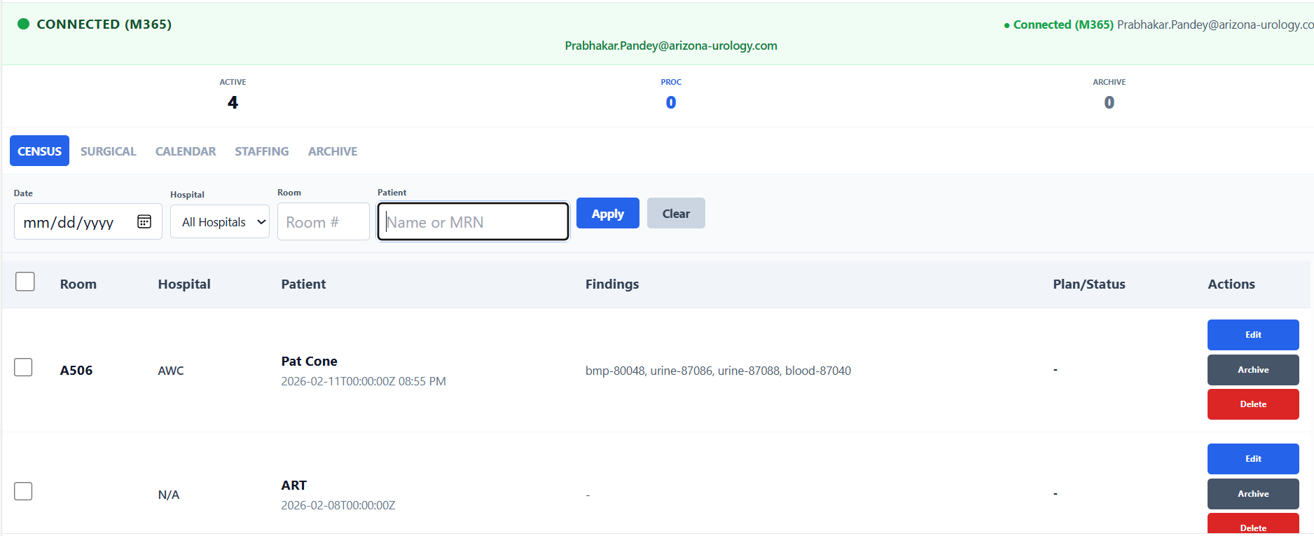

- Edit allows me to edit that particular entry. So, if I hit “Archive” will it complete my entry and not show up on this list?
- MRN: what is the purpose of this? If I enter a MRN, will that patient record show up for editing purposes?

Radiology:
Type of Imaging | Location/Description
Xray
Ultrasound
CT Scan
MRI Scan
PET Scan
Nuclear Scan

Result: NORMAL/ABNORMAL
1
2
3
4
5

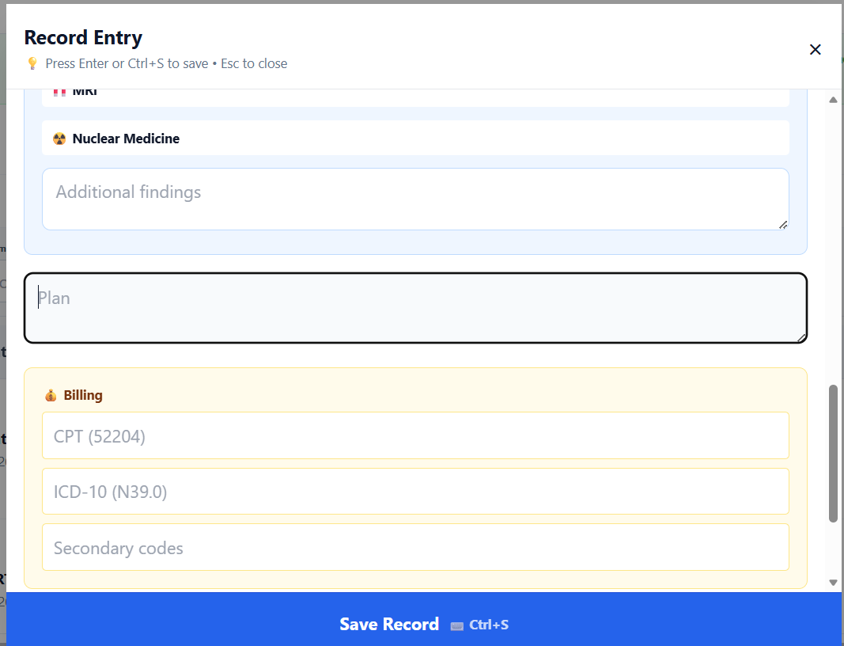
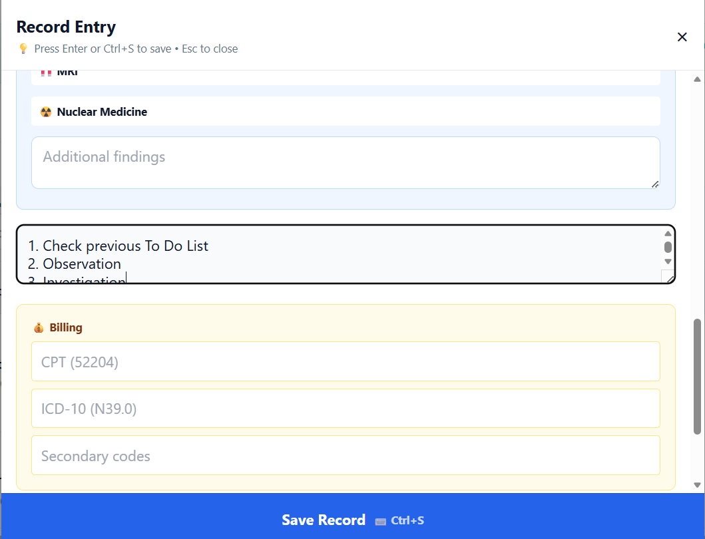
- Check previous To Do List
- Observation
- Investigation
  - Labs
  - Radiology
  - Consultation/2nd Opinion
  - Special Investigations
  - Procedure: Diagnostic
- Pharmacotherapy
- Physical/Behavioral Therapy
- Surgical Procedure (Therapeutic)
- Discharge
  - General Instructions
    - Activities
    - Diet
    - Restrictions, if any
  - Pharmacotherapy
  - Follow up Investigations
  - Office Follow up
    - Expected time
    - Call office if
    - Return to ER if

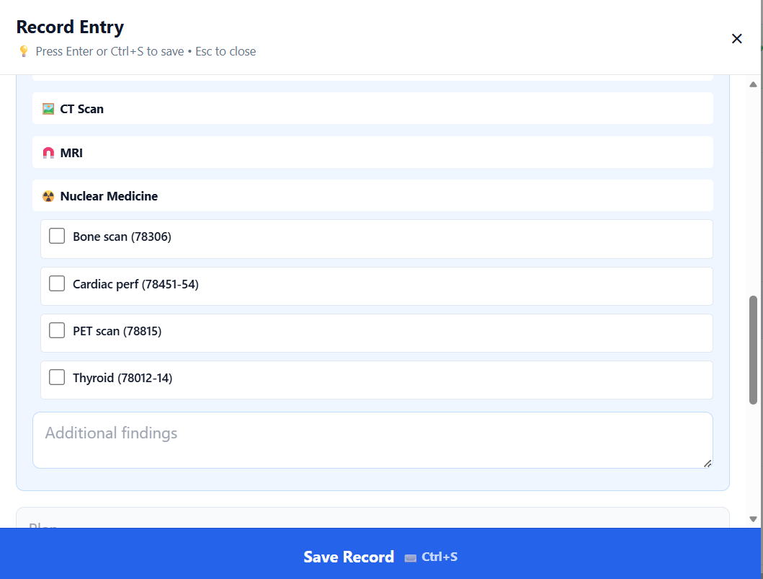
Nuclear Medicine:
Name | NORMAL/ABNORMAL | Findings
Bone Scan
LASIX RENAL SCAN
V/Q (PULMONARY)
CARDIAC STRESS TEST
PSMA SCAN

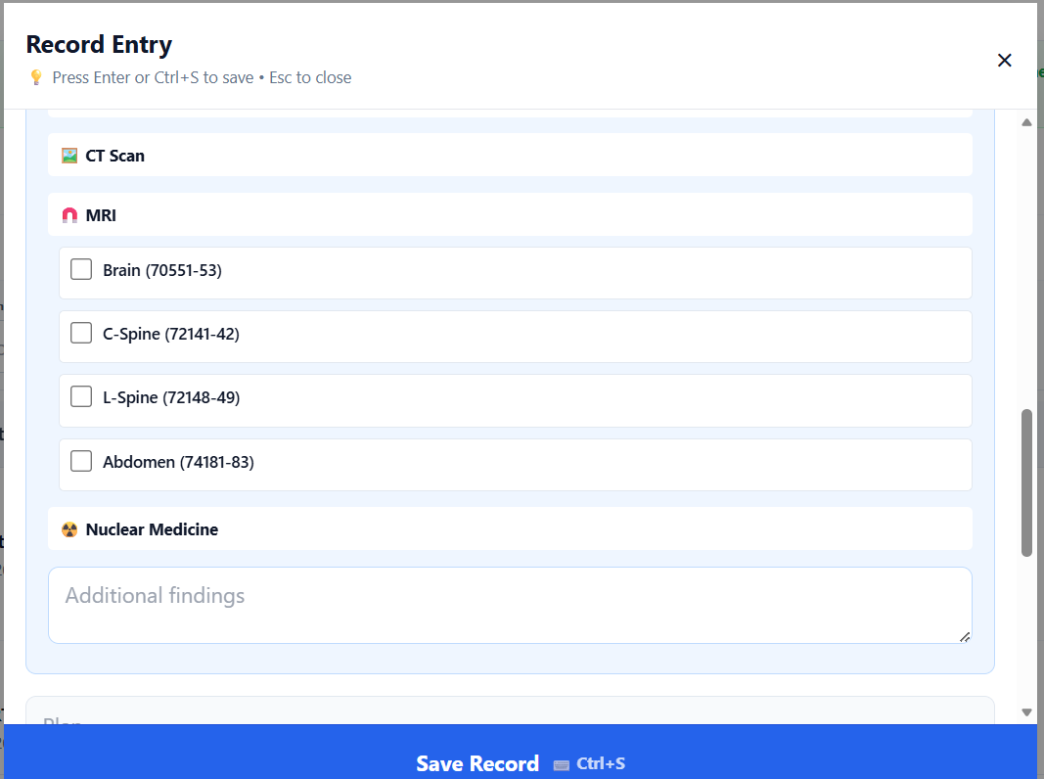
DATE | Name | NORMAL/ABNORMAL | Findings
 | MRI ABD/PELVIS WO
 | MRI ABD/PELVIS W
 | MRI ABD/PELVIS
 | MRI UROGRAM
 | MRI ANGIOGRAM (RENAL)

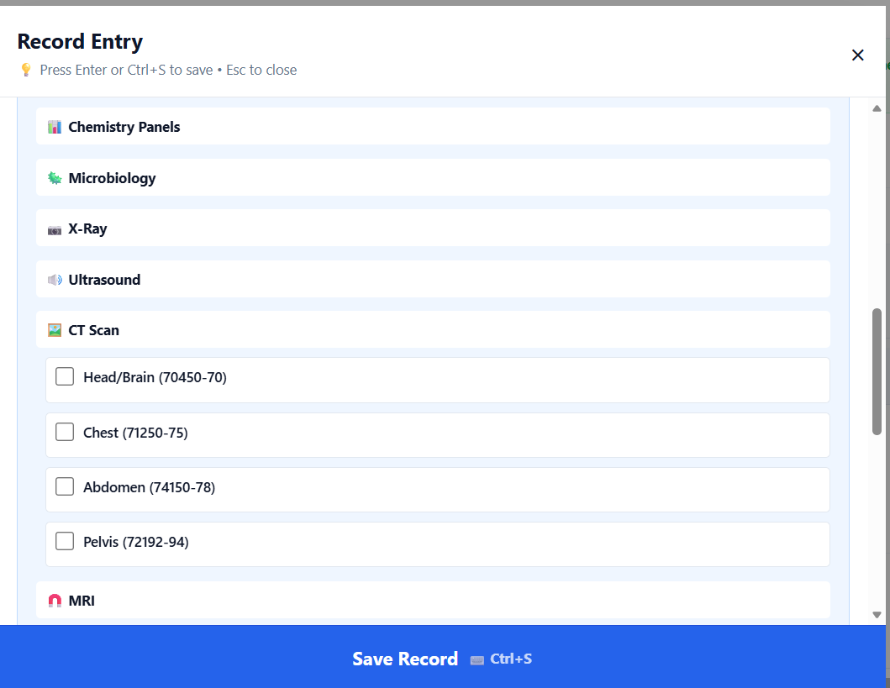
DATE | Name | NORMAL/ABNORMAL | Findings
 | CT ABD/PELVIS WO
 | CT ABD/PELVIS W
 | CT ABD/PELVIS
 | CT UROGRAM
 | CT ANGIOGRAM (RENAL)
 | CT CHEST WO
 | CT CHEST W
 | OTHER

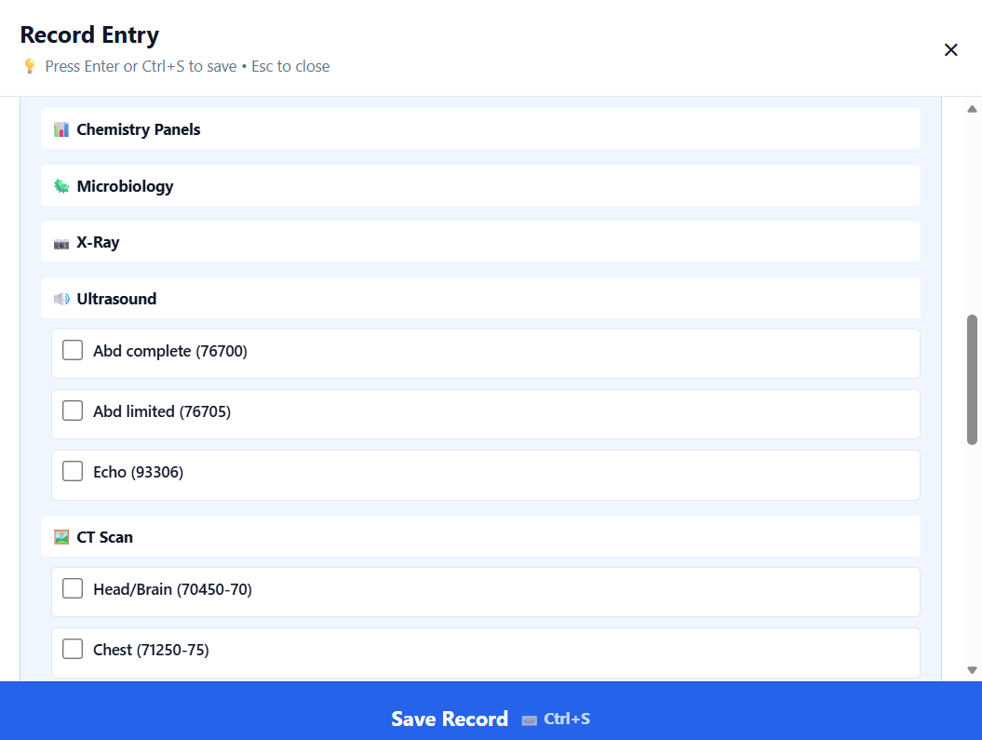
ULTRASOUND:
DATE | Name | NORMAL/ABNORMAL | Findings
 | RENAL ULTRASOUND
 | ABDOMEN
 | RENAL DOPPLER
 | SCROTAL US
 | OTHER

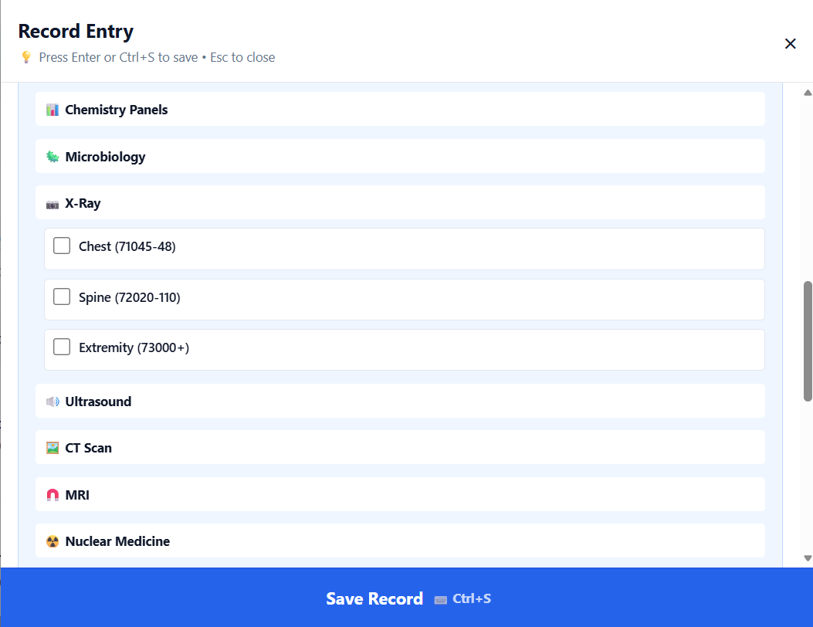
X-RAY:
DATE | Name | NORMAL/ABNORMAL | Findings
 | ABDOMEN FLAT/UPRIGHT
 | ABDOMEN KUB
 | ABDOMINAL SERIES
 | CHEST P/A
 | CHEST PA/LATERAL
 | OTHER

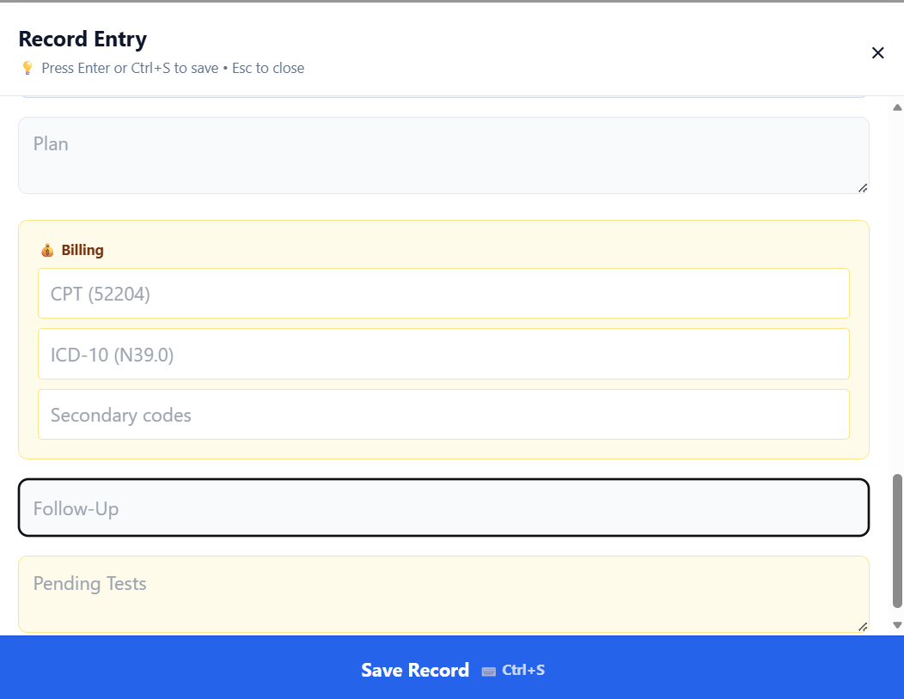
FOLLOW UP (EMAIL/FAX/PRINT)
 | ACTIONS | ACTIONS
DATE |  | SCHEDULE
ACTIVITIES
DIET
RESTRICTIONS
ALERTS |  | CALL/RETURN TO ER
LABS TO DO | PENDING AND/OR ADDITIONAL
RADIOLOGY | PENDING/ADDITIONAL
CONSULT | PENDING/ADDITIONAL

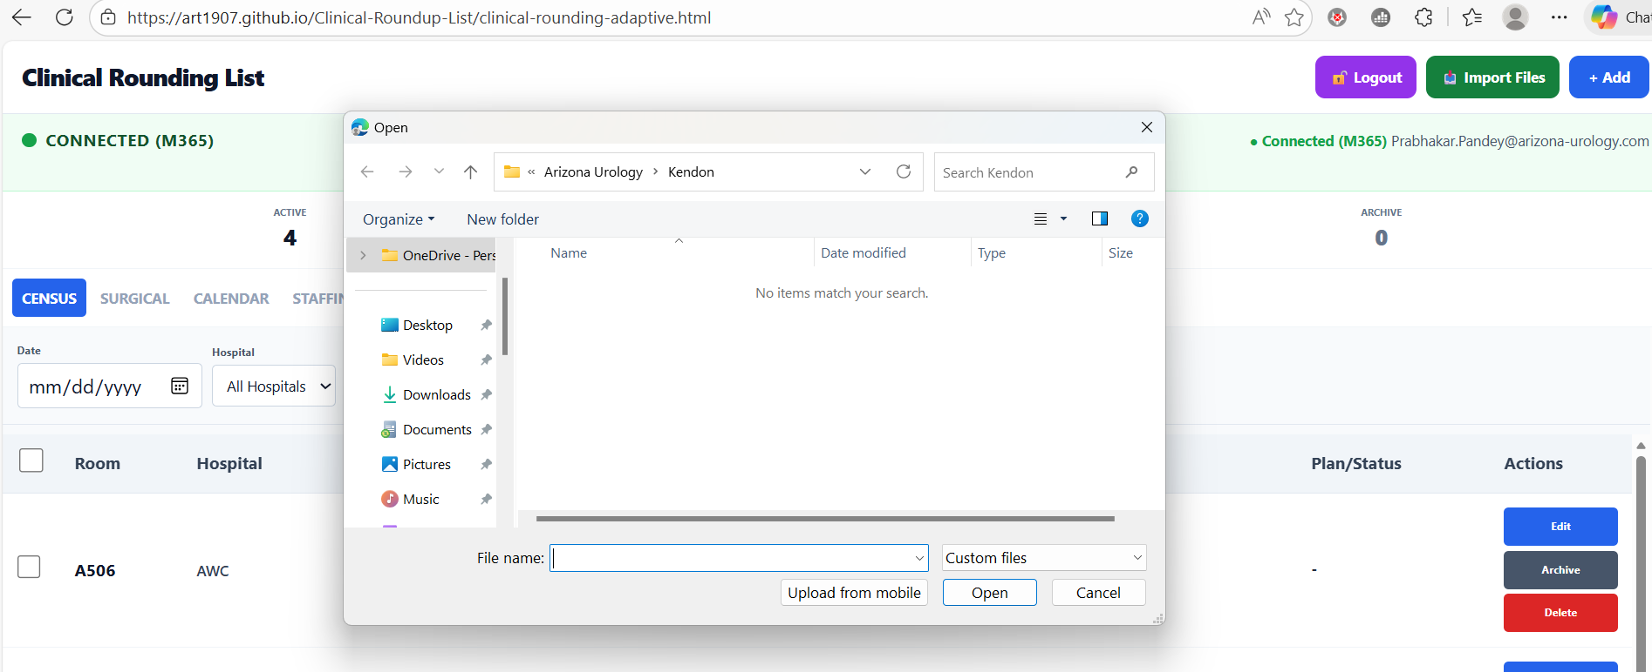
“IMPORT FILES”:
- Interesting Concept
- Patient specific data storage
- Import from:
  - EMR – PDF/IMAGE COPY ETC
  - EMAIL/TEXT/WHATSAPP ATTACHMENT SAVED ON USER’S STORAGE FOLDER
- THIS BUILDS UP CONCEPT FOR PATIENT SPECIFIC MEDANALYSE ACCOUNT (“ARCHIVE” BUILDS UP USER SPECIFIC MEDANALYSE ACCOUNT.

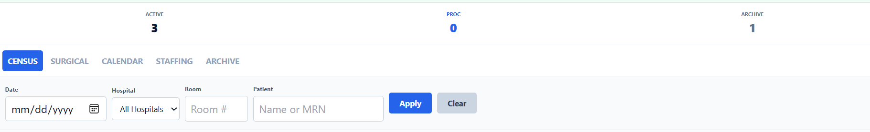
Can archived data be accessed? Right now it does not.

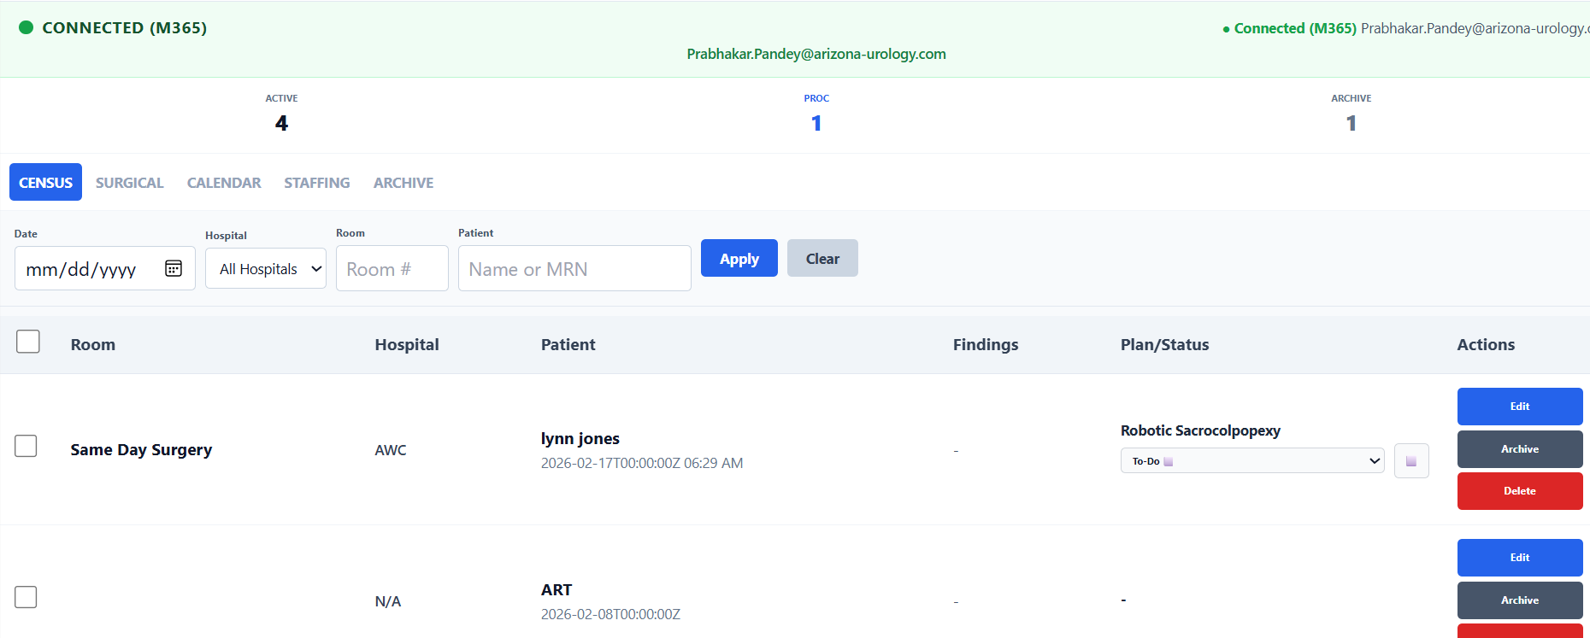
Same Day Surgery was created under surgical tab. I see that number of procedures is now on and “Active” number is 4. Surgery tab also shows the name of the patient.
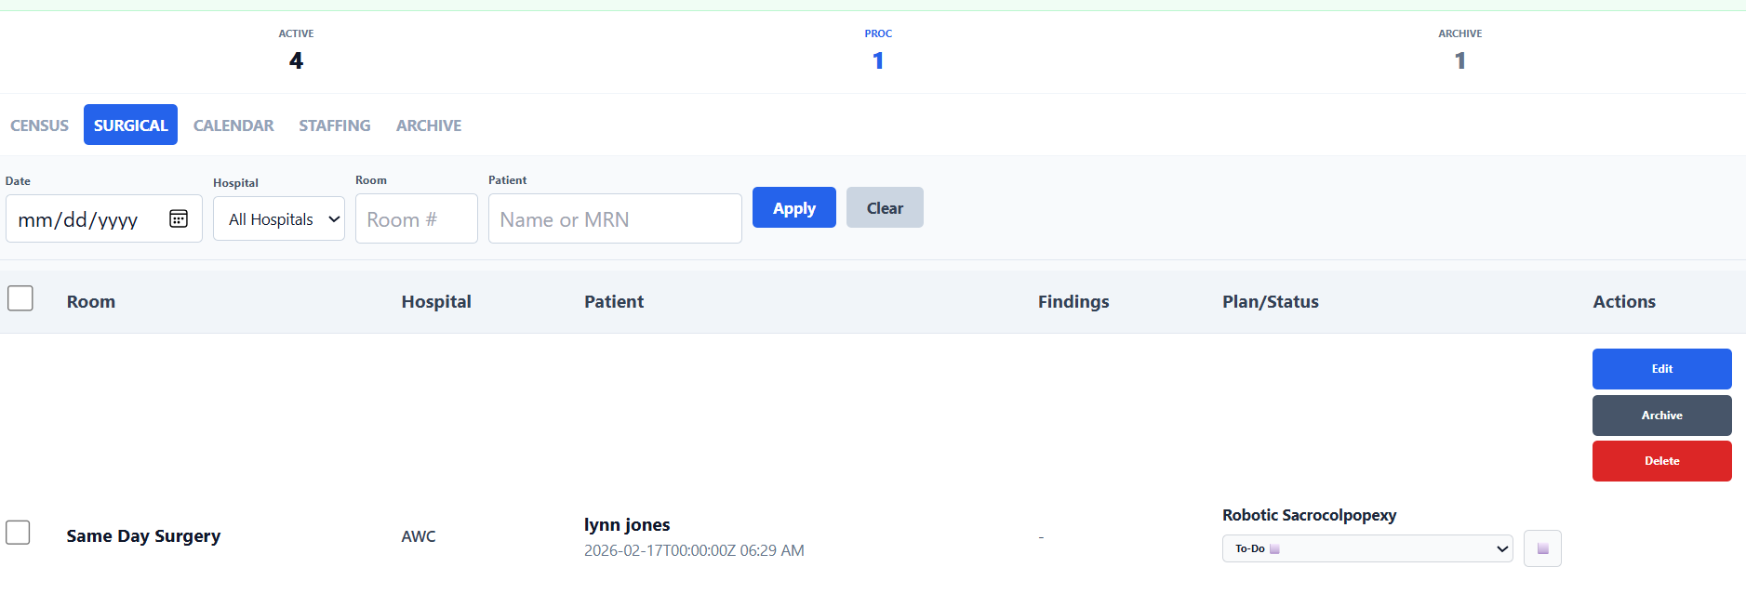

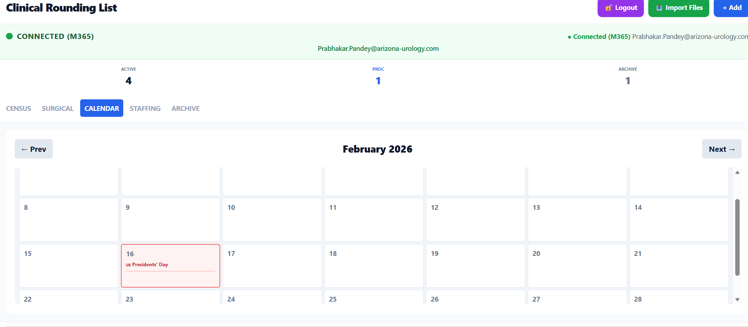
Calendar:
PATIENT/ADMINISTRATIVE
PATIENT
NAME | CATEGORY | ACTION | REVIEW DATE
 | LAB/RADIOLOGY/MEDICATION ETC | REVIEW/ORDER

ADMINISTRATIVE
CATEGORY | ACTION | REVIEW DATE

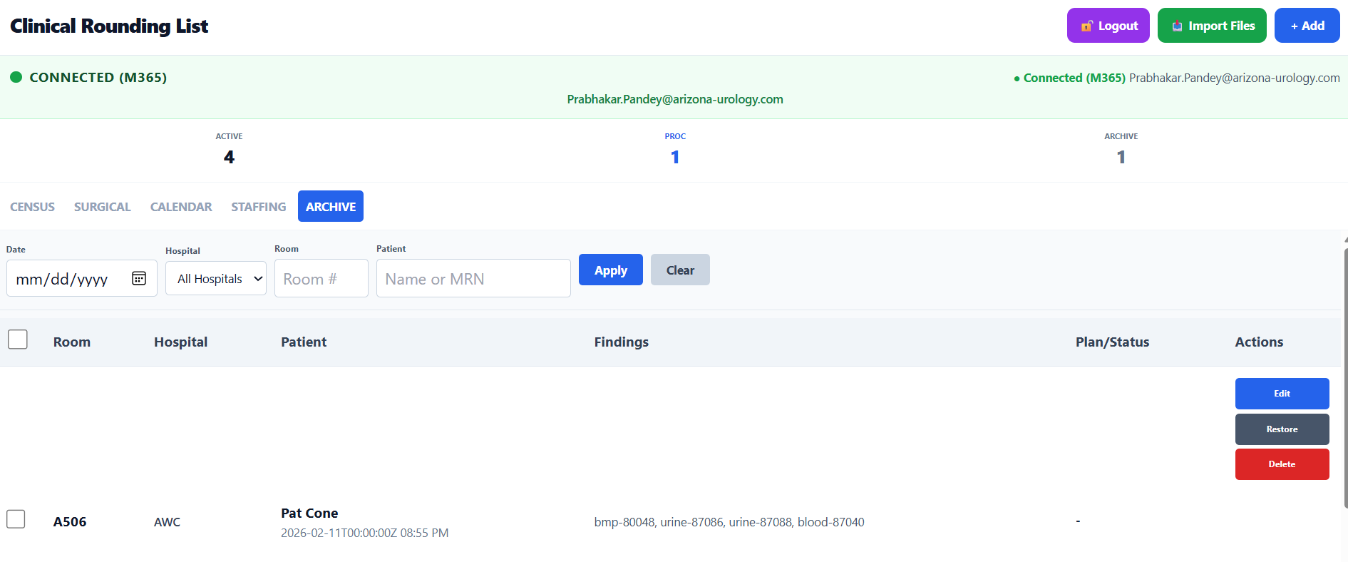NICE.

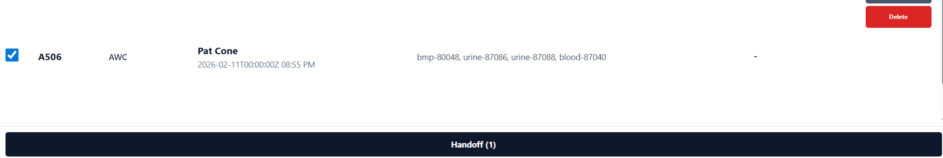
Hand Off is activated when a patient row is checked.
What does hand off mean?
Who is at the receiving end?
Does that still remain in its place within the system.

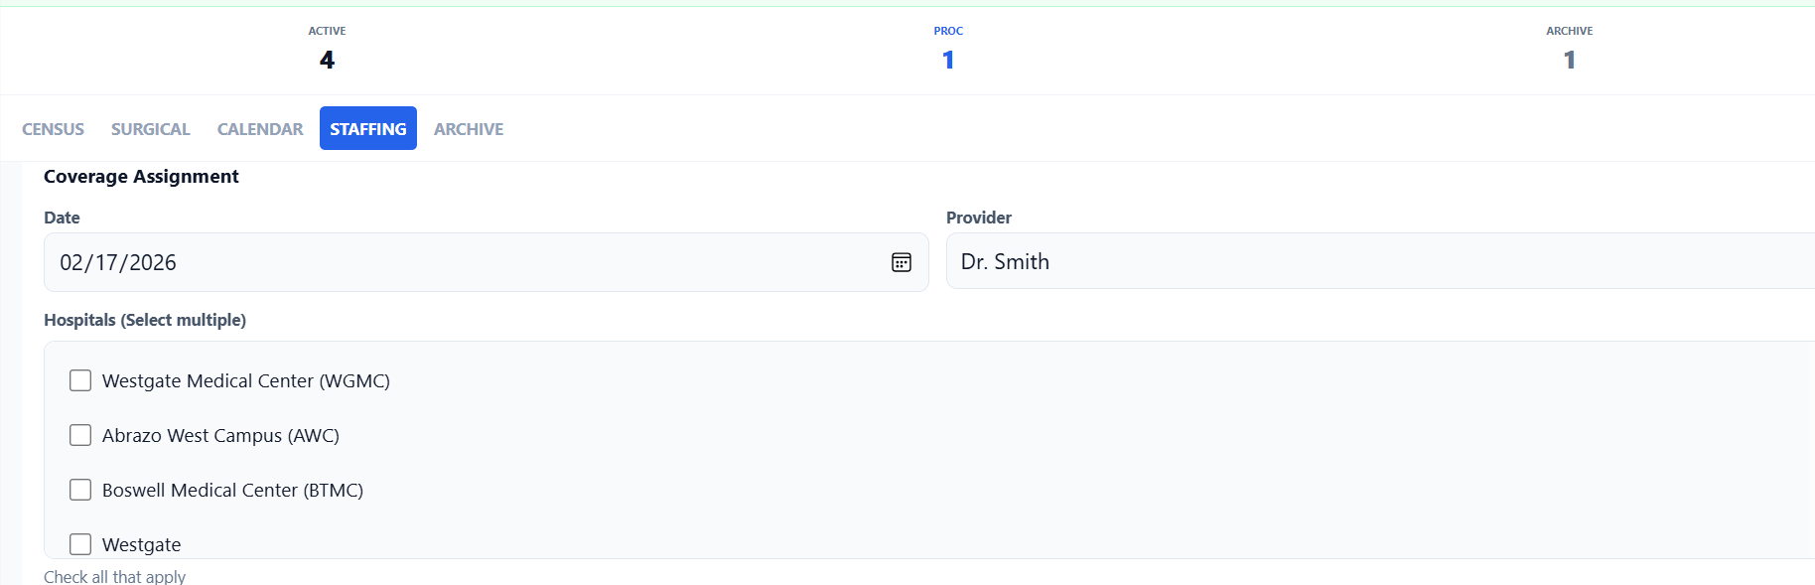

DATE | PROVIDER (PHYSICIAN) | PROVIDER (MID LEVEL)

Scheduling Surgical Procedures:
This can be elective – patient is mostly scheduled by Surgeon and Office Scheduling System. Some patients may be in hospital and be scheduled on urgent and emergency basis. Patients who are in hospital will be on rounding list – how will they be shown to be undergoing a procedure.
Date
Patient
Surgeon
Assistant
Procedure
CPT
ICD
Required Instruments
Required Resources (Radiology etc.)
Path (Frozen Section) | Yes/No
Insurance Name
Insurance Approval | Approved/Not Required
Industry Representation | Required/Not Required
Additional Comments, if any

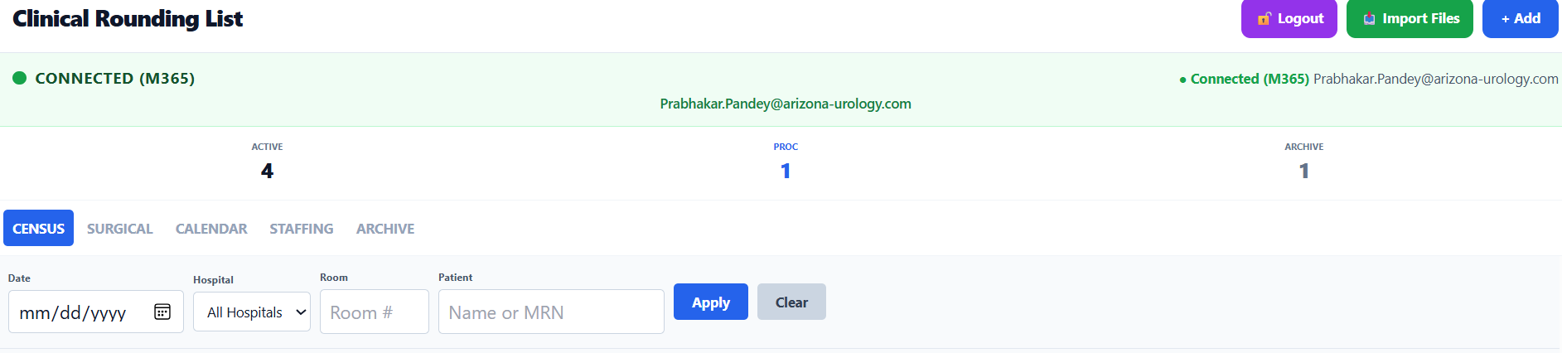
If we added name of the provider (physician/mid-level) in the search/filter section, would that provide specific information for that provider? How difficult would it be to do in this setting?

DATA AGGREGATION:
How difficult would it be to perform following:
- Demographic Assessment:
  - Number of patients: Daily, Weekly, Monthly
  - Geographic Distribution: ZIP code (we are not collecting that patient information directly). We do have that information embedded in factsheets.
  - Gender distribution
  - Age distribution
- Providers
  - Number of providers: Daily/Weekly/Monthly
  - ICD
  - CPT
  - Instrument Usage
  - Patient Demographics
- CPT and E&M related data
  - Daily charges or Charges at periodic intervals
    - Provider specific
    - Location specific
- ICD related data
  - Work inventory and revenue stream
  - Analysis of Charges and Revenue Stream should help understand impediments and bottlenecks
    - Can revenue stream be tapped more efficiently?
    - Inherent blocks to stream

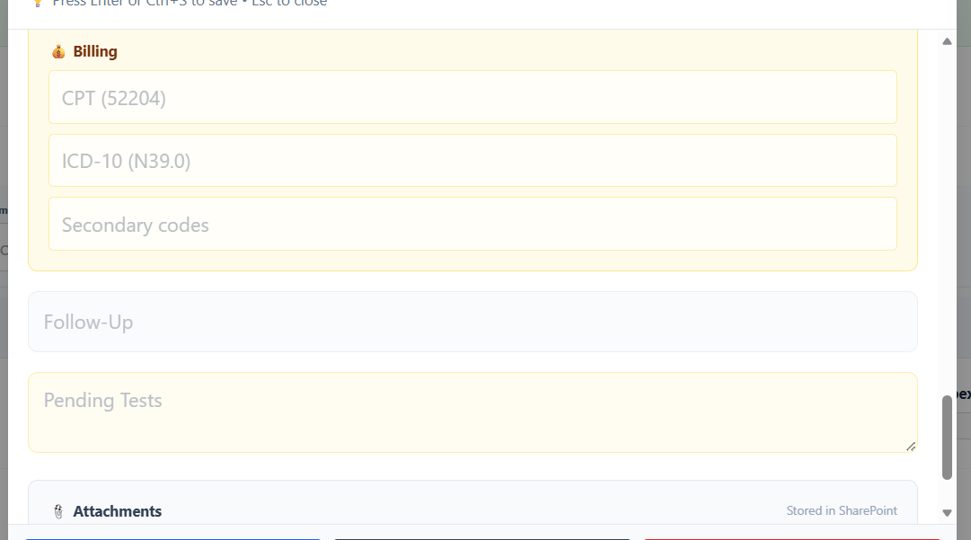
BILLING:
DESCRIPTION | ICD | E&M | CPT
Initial Consult | N71 | 99253
Cystoscopy | N71 |  | 52000

